Senior Officers' Mess Annex (Page 3)  13. If more than one toast is to be drunk, the procedure is repeated.  MOVEMENT IN THE DINING ROOM  14. Movement in or out of the dining room, other than by Mess staff during the course of the meal, is not permitted.  15. After the toast/s, and any piper's contribution to the programme, the PMC will normally announce a short recess.  LEAVING THE MESS  16. Guests should not normally leave the Mess before the guest of honour, but if it becomes essential that they do so, they should first bid farewell to the guest of honour, and the Honorary President of the Mess or the PMC. |  | 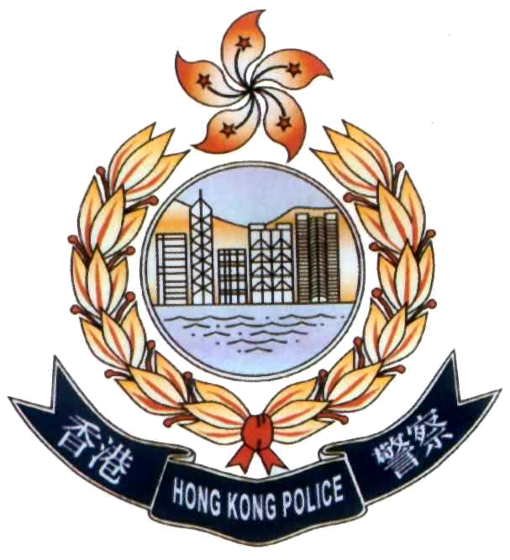  SENIOR OFFICERS' MESS  MEMBERS' GUIDE
Senior Officers' Mess Page 1  MEMBERSHIP ELIGIBILITY  Full membership of the Hong Kong Police Senior Officers' Mess is open, essentially, to all officers of the rank of superintendent and above and, subject to certain conditions, civilian equivalents working within the Force. The Mess also offers associate, life, honorary, and temporary membership to certain other persons. For further details of this and other formal matters concerning the Mess, members are referred to the Constitution, available on request from the Mess Committee.  SUBSCRIPTIONS  2. Full associate and temporary members pay a monthly subscription.  3. On the occasion of a full member's departure from the Force, each other full member is levied a standard sum, the aggregate of which is used to purchase a present for the member concerned.  MESS COMMITTEE  4. The Honorary President of the Mess is the Commissioner. The President of the Mess Committee and the principal office bearers are elected at the annual general meeting which is held in May. The Mess Committee meets once every two months and the minutes with function application forms as appropriate are kept in the Mess‘s office for members’ reference. |  | Senior Officers' Mess Annex (Page 2)  6. All gentlemen remain standing behind their chairs until the last lady has taken her seat. Gentlemen may then sit, taking their cue from the PMC.  DRINKS  7. Drinks during the meal are limited to those which are on the menu. It is not permitted to order drinks from the bar during the meal.  8. Port remains on the side of the table and is not passed across. It always moves to the left.  TOASTS  9. The timing of toasts depends on whether the meal is Chinese or Western style. If it is Chinese cuisine, toasts are made prior to the commencement of the meal whilst, when a Western style meal is served, toasts are drunk after the port was passed.  10. The procedure is for the PMC to arise, and call upon Mr or Ms Vice to make the toast.  11. Mr or Ms Vice, who is normally the most junior member present, will then stand and call.  "Ladies and Gentlemen, please be upstanding."  12. When everyone has risen to their feet, Mr or Ms Vice proposes the toast.
Senior Officers' Mess Annex (Page 1)  FORMAL MESS DINNERS  Prior notice is given by the Honorary Secretary of the Mess, specifying the date, time and nature of such functions. Members are also informed whether or not the function is solely for Mess members, and the dress required. Occasionally, where this is known and may be of influence, the approximate cost of a particular function may be given.  DRESS  2. At formal Mess dinners, the normal dress is mess kit for male members, and formal attire for females - both members and non-members. Other gentlemen, and who are not members of a disciplined service or the military, are expected to wear a dinner jacket and black tie.  3 Exceptionally, for example where a newly promoted male officer has not had an opportunity to acquire mess kit, he may be permitted to attend a formal function in a dinner jacket. Courtesy demands, however, that they should seek permission from the President of the Mess Committee (PMC) before so doing.  SEATING  4. At a formal Mess dinner, a full seating plan is prepared, and members should note their position prior to entering the dining room. Each gentleman should escort the lady shown on the plan as seated on his right, into the dining room. The lady is escorted on the left arm.  5. The guest of honour (with his or her escort) will follow the Honorary President of the Mess into the dining room. The Honorary President of the Mess will normally escort the guest of honour's spouse or partner. The PMC will proceed next, with other diners shown as seated at the top table following (escorting a lady as necessary). Other members/guests then follow. |  | Senior Officers' Mess Page 2  FACILITIES  5. The Mess is situated on the 6th and 7th floors of Caine House, Police Headquarters. On the 6th floor there is an anteroom which includes a bar and a dining room which seats 150 persons. On the 7th floor there is a small lounge including a bar, and a function room. The 7th floor may be used for private functions up to a party of 12 for lunch and 30 for cocktail parties.  6. The Mess offers lunch daily except Saturdays and public holidays.  DRESS IN THE MESS  7. Dress for formal mess dinners is covered below. Dress for less formal functions is normally lounge suit, unless otherwise advised. Generally, dress should be at least 'smart casual', other than on Saturdays when members may 'dress down' if they wish.  USE OF THE MESS FOR PRIVATE FUNCTIONS  8. Any member of the Mess may apply in writing to the Mess Committee to use part or all of the Mess for a private function. No charge is made for hiring the Mess but catering charges will be covered at cost plus 10 per cent. A member applying to hire the Mess thus will also be held responsible for any damage or breakages.
Senior Officers' Mess Page 3  FORMAL MESS DINNERS  9. These are held periodically, normally either to dine in a particular person or bid farewell to departing members, if they so wish.  10. There is a degree of etiquette associated with such functions and a note on this is annexed.  11. Formal dinners may feature either Chinese or Western cuisine, in accordance with the wishes of the guest of honour.  OTHER FUNCTIONS  12. Departing members may elect, as an alternative to a formal dinner to have a luncheon, cocktail party or a lunch with the Mess Committee, to mark their departure from the Force  13. Other functions such as the Christmas luncheon are announced in Mess Committee meeting minutes.  MESS BILLS  14. Mess services are provided on credit. Members are encouraged to settle bills through autopay or, otherwise, promptly. Members have signing rights at the Auxiliary Headquarters, Police College and Police Tactical Unit officers' messes.  SUGGESTIONS  15. The Mess Committee welcomes suggestions intended to improve the Mess and its facilities. A suggestions book is maintained for the purpose and is placed on the anteroom bar. |  | Senior Officers' Mess Page 4  GUESTS  16. Members are encouraged to invite guests to the Mess, such guests being the responsibility of their hosts. Such guests may include inspectorate and junior officers who should be suitably attired in civilian clothes.  PRESENTATIONS  17. Full members will receive a present from the Mess on retirement.  DONATIONS TO THE MESS  18. Donations to the Mess are always welcomed and it is customary, but not obligatory, to make a donation on the occasion of one's departure from the Force.

November 2010 (Revised)

